**Malwarebytes PREMIUM 4.1.0 - LIFETIME METHOD | 8.62 MB**  
  
**1. Guide:**  
***Note: Application requires Admin privileges***  
  
Allow run the program as an administrator.

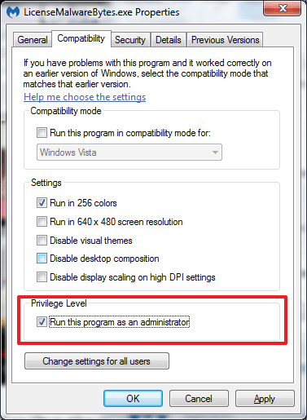

Run LicenseMalwareBytes.exe in commandline (CMD) as **administrator**. For more details, please run LicenseMalwareBytes.exe --help.

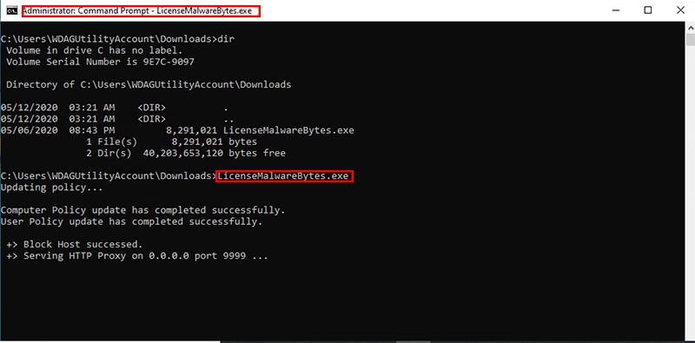

Run crack.bat as administrator

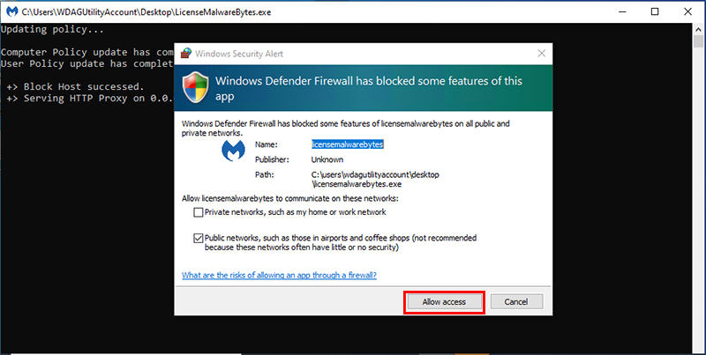

Open MalwareBytes, select **Settings > General**. Turn on **Proxy server**. After enter IP into **Address** and PORT into **Port**.

Address: 127.0.0.1  
Port: 9999

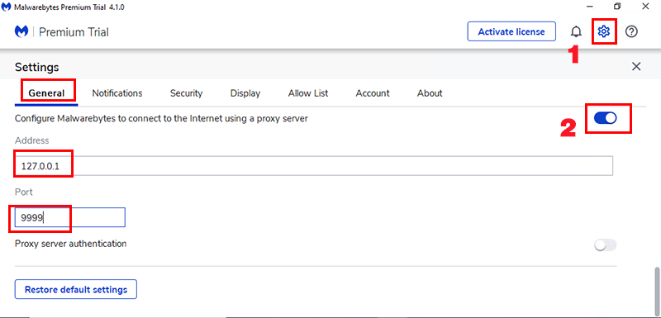

After that, switch tab **Account**.

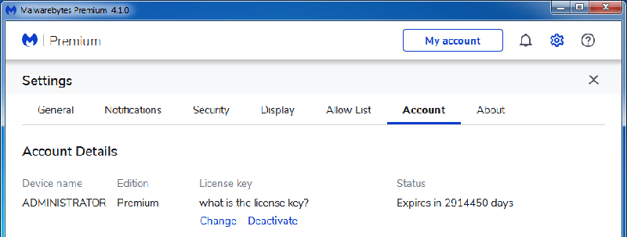

Not yet, return tab **General**. Go to **Proxy server**, turn off it.

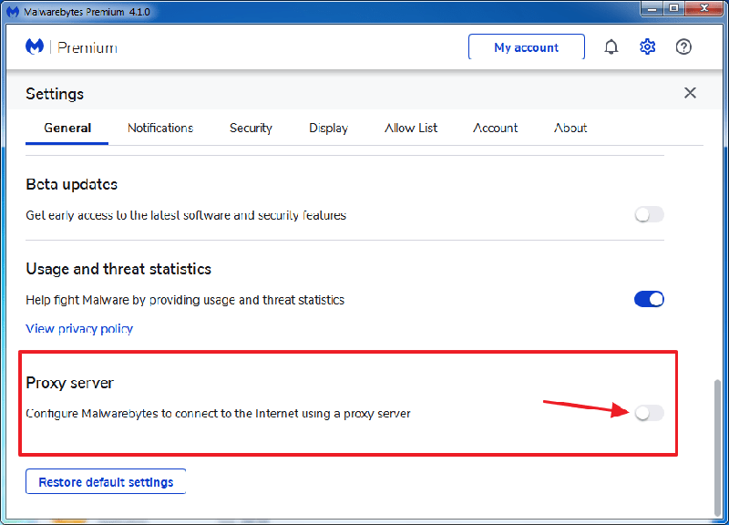

Return tab **Account**. You will see.

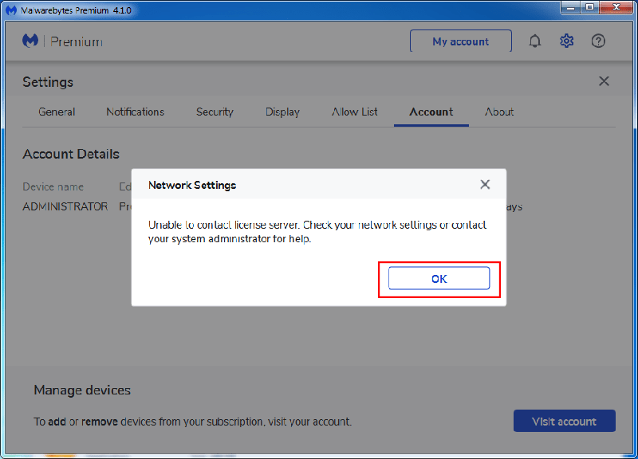

**Don’t worry about it. Click OK and done.**



**NOTE:** Some screenshots are cut off because I tried it in "Windows Sandbox", others are the original ones from the author's thread.  
  
**2.1 OTHER INSTALL SCREENSHOT**

Install the latest version setup from Malwarebytes official website

